Watkins Community Center (WCC) Usage Guidelines
Multi-Purpose Room

“This facility is the result of the vision and cooperative efforts of many of the citizens of the Honea Path area. We hope that you will appreciate and respect WCC as much as we do. Please enjoy your stay with us and come back to visit with us soon.”
WCC Board of Directors

Reservations

All fees are described in the attached WCC Facility Use Fee Schedule. Because reservations prevent any additional reservation of the selected facility, RESERVATION DEPOSIT FEES ARE NON-REFUNDABLE.

Reservation Date(s): ___________________ Reservation Time period: ________________

Purpose: ____________________________

Reservation Deposit Amount: ____________

USE FEE BALANCE DUE WHEN REQUESTING ROOM KEY.

Room Use Fee (minus deposit): _____________

Microphone/Cable Use Fee: _____________

Cleaning Deposit: _____________

Total Balance Due: _____________

ALL ROOMS ARE ACCESSIBLE ONLY DURING THE TIME PERIOD INDICATED ON THIS FORM.

Facility Use Fee Schedule

Watkins Community Center is made available for the maximum benefit of the community. It is the desire of the Board of Directors to keep the facility in good repair so that the Center will be available for future generations. The following schedule has been set to cover the cost of operations, maintenance and upkeep of the facility.
Multipurpose Room:
Schedule Monday-Sunday Reservation Deposit
Full Day $300.00 $150.00
2 ½ Day Special Event Package $600.00 $300.00*

A $100.00 cleaning deposit must be paid at the time the room is reserved. The cleaning deposit will be refunded after the date of use provided that the multipurpose room was properly cleaned as required by the WCC Usage Guidelines.
*(The reservation for the package will begin at 12:00 noon for the first day, followed by 2 full days’ usage, ending at midnight on the last day. Room cleaning must be completed by midnight of the last day).

Microphone and Cable $50.00

Payment of Fees
Payment may be made by cash, check, Venmo, or Cash App. Checks should be made payable to Watkins Community Center. Reservations are not final until the non-refundable deposit is received.

Usage Guidelines:
- The key to the facility may be obtained from the Key Box once the access code to the Key Box is provided. The microphone and cable are available upon request.

- Alcoholic beverages are prohibited in the building and on the grounds. Tobacco products (including vaping products) are prohibited in the building.

- DO NOT nail, staple, or place tape on the walls, ceiling, or floor. DO NOT damage the facility in ANY manner. Damages incurred may be interpreted as vandalism and may result in legal consequences. All deposits will be held until any damage issues are resolved.

- If you choose to have your cleaning deposit refunded, the area utilized must be cleaned according to the attached guidelines. If you would like for the area used to be cleaned by our professional, you must note below at the time the deposit is made. At this point, the deposit will not be refunded. Please check the appropriate selection:
  - I will be responsible for cleaning the facility _____
  - I would like for the facility to be cleaned by the WCC professional and understand that the deposit will be forfeited _____

- Set the desired room temperature on the wall thermostat according to the instructions next to the thermostat. Do not readjust the thermostat when leaving. It will reset automatically.

- Turn off all lights and appliances in the kitchen area except for the refrigerator and the ice maker.

- Make sure that everyone is out of the facility before leaving.

- After assuring that all exterior doors are locked, the key, cleaning sheet, and microphone (if applicable) should be deposited in the Key Drop box as the renter responsible leaves the building.

- Please report any damage or needed repairs as soon as possible to 864-369-2466, ext. 9 or 864-713-2139 during normal business hours and email the community center at contactwcchp@gmail.com.
- The undersigned agrees to reimburse WCC for any damages, intentional or unintentional, caused by the undersigned or guests of the undersigned during the use of the facility.

- WCC is not responsible for any personal injuries or property damage or loss (such as damage to vehicles, etc.) which occur on the WCC premises. In case of emergency, dial 911.

- WCC is not responsible for any acts of nature which may cause inconvenience or cancellation of your function.

- All deposits will be refunded once the facility has been cleaned, any damage repaired with a final inspection, key and microphone equipment returned in working condition.

WARNING: UNDER NO CIRCUMSTANCES IS THE USE OF SMOKE CREATING DEVICES PERMITTED ANYWHERE WITHIN THE CONFINES OF THE BUILDING!

Multi-Purpose Room Cleaning
(Initial each completed item)

____ All trash must be placed in plastic bags, tied securely, and deposited in the outside garbage dumpster behind the kitchen.

____ Tables must be “broken down” and placed in the storage room to the right of the front door. Chairs must be folded and placed on rolling racks. Leave these racks positioned in the multi-purpose room by the walls next to the windows. Remember to bring in racks that may have been moved to the hallway.

____ Kitchen must be cleaned and floor damp mopped with clear water only, but only if used.

____ Sinks and tables in kitchen should be cleaned, if used.

____ All food must be removed from the refrigerator and warming units and taken from the building.

____ Turn off all appliances except for the refrigerator and the ice maker.

____ If food and beverages are served, the hardwood floor in the multi-purpose room should be initially dry mopped and then lightly damp mopped. The mop should contain a minimal amount of clear water only. Otherwise, dry mop only.

____ Restroom toilets should be flushed and all trash removed.

____ Make sure that all water faucets are turned off.

____ Do not readjust thermostats when leaving.

____ Turn off all lights including the restrooms behind the stage and in the kitchen. Do not turn off the hallway restroom lights. Those lights are automatic.

____ Lock all exterior doors.

____ Report any damages. Please explain the nature of the damage on the back of this page.
EACH ITEM MUST BE INITIALED AS COMPLETE.
Responsible Party: (print name) _______________________________________
Address:_______________________________________
_______________________________________ Phone:_______________________________
Signature: ____________________________________ Date: ______________________________
Place this form and key in the Key Drop Box when vacating the facility. If applicable, place the microphone and cable in the carrier bags and place in the Key Box as well. All must be accomplished to request a refund of the cleaning charge.
Refund Amount Approved: $___________________ Clerk’s Initials: ________________

Acknowledgement of Receipt of Watkins Community Center Usage Guidelines

Date: _________________________

Responsible Party
Print Name: _________________________________________
User Signature: _______________________________________
Mailing Address: _____________________________________
______________________________________
Email Address: _______________________________________
Telephone: __________________________________________
Secondary Contact: ____________________________________
Telephone: __________________________________________

Witness: ____________________________________________

NOTE: Information on this page must be given at the time the reservation and deposits are made.

How to Obtain and Return Rental Key
- The Code to the Key Box will be given to via email, text, or phone call 2 hours prior to the rental time.
- Located in Middle of Watkins Community Center at Double Doors, you will find a key box. It is located to the left of the doors (facing doors).
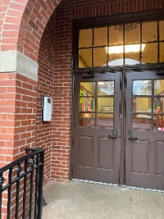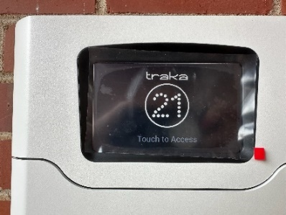
- The box will say “Enter Pin”. Pin Code given to you for your code is to be put onto this screen. Enter numerical code then press button.
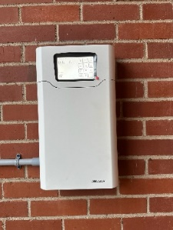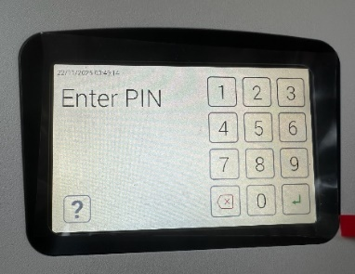
- Pull on door to open from the right side. Door will swing to the left. Keys will be hanging in as shown below. Key for the rental will be lit up green. Pull key from box. Shut door FULLY once key obtained.
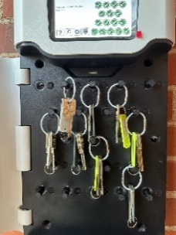
- Prior to leaving the facility after the event is over. Return the key to be box located adjacent to Double Middle Doors. Pull door down and drop in key and exit through the double door.
