Watkins Community Center (WCC) Usage Guidelines
Classrooms

“This facility is the result of the vision and cooperative efforts of many of the citizens of the Honea Path area. We hope that you will appreciate and respect WCC as much as we do. Please enjoy your stay with us and come back to visit with us soon.”
WCC Board of Directors

Reservations

All fees are described in the attached WCC Facility Use Fee Schedule. Because reservations prevent any additional reservation of the selected facility, RESERVATION DEPOSIT FEES ARE NON-REFUNDABLE.

Reservation Date(s): ___________________ Reservation Time period: ________________

Purpose: ____________________________

Reservation Deposit Amount: ____________

USE FEE BALANCE DUE WHEN REQUESTING ROOM KEY.

Room Use Fee (minus deposit): _____________

Cleaning Deposit: _____________

Total Balance Due: _____________

ALL ROOMS ARE ACCESSIBLE ONLY DURING THE TIME PERIOD INDICATED ON THIS FORM.

Use Fee Schedule

Watkins Community Center is made available for the maximum benefit of the community. It is the desire of the Board of Directors to keep the facility in good repair so that the Center will be available for future generations. The following schedule has been set to cover the cost of operations, maintenance and upkeep of the facility.

Classrooms 7, 8, and 9:
Schedule Monday-Sunday Reservation Deposit
2 hours $40.00 $40.00
4 hours $70.00 $40.00
8 hours $105.00 $55.00
Conference Room 4:
Schedule Monday-Sunday Reservation Deposit
2 hours $45.00 $45.00
4 hours $75.00 $45.00
8 hours $125.00 $70.00
A $40.00 cleaning deposit must be paid at the time the room is reserved. The cleaning deposit will be refunded after the date of use provided that the classroom was properly cleaned as required by the WCC Usage Guidelines
Payment of Fees
Payment may be made by cash, check, Venmo, or Cash App. Checks should be made payable to Watkins Community Center. Reservations are not final until the non-refundable deposit is received.

Usage Guidelines:
- The key to the facility may be obtained from the Key Box once the access code to the Key Box is provided
- Alcoholic beverages are prohibited in the building and on the grounds. Tobacco products (including vaping products) are prohibited in the building.
- DO NOT nail, staple, or place tape on the walls, ceiling, or floor. DO NOT damage the facility in ANY manner. Damages incurred may be interpreted as vandalism and may result in legal consequences. All deposits will be held until any damage issues are resolved.
- If you choose to have your cleaning deposit refunded, the area utilized must be cleaned according to the attached guidelines. If you would like for the area used to be cleaned by our professional, you must note below at the time the deposit is made. At this point, the deposit will not be refunded. Please check the appropriate selection:
  - I will be responsible for cleaning the facility _____
  - I would like for the facility to be cleaned by the WCC professional and understand that the deposit will be forfeited _____
- Set the desired room temperature on the wall thermostat according to the instructions next to the thermostat. Do not readjust the thermostat when leaving. It will reset automatically.
- Turn off room lights when leaving.
- After locking the facility, the key should be immediately returned to the drop box located at the Double Middle Doors (see attached instruction).
- Please report any damage or needed repairs as soon as possible calling 864-369-2466, ext. 9 or 864-713-2139, during normal business hours and email the community center at contactwcchp@gmail.com.
- The undersigned agrees to reimburse WCC for any damages, intentional or unintentional, caused by the undersigned or guests of the undersigned during the use of the facility.
- WCC is not responsible for any personal injuries or property damage or loss (such as damage to vehicles, etc.) which occur on the WCC premises. In case of emergency, dial 911.
- WCC is not responsible for any acts of nature which may cause inconvenience or cancellation of your function.
- All deposits will be refunded once the facility has been cleaned, any damage repaired with a final inspection, and key is returned.

WARNING: UNDER NO CIRCUMSTANCES IS THE USE OF SMOKE CREATING DEVICES PERMITTED ANYWHERE WITHIN THE CONFINES OF THE BUILDING!

Classroom Cleaning
(Initial each completed item)

____ All trash must be placed in plastic bags, tied securely, and deposited in the outside garbage dumpster behind the kitchen. Bags and brooms are located in the corner closet next to the classroom door.

____ All food and drink must be removed from the building.

____ Clean and organize tables and chairs. Tables and chairs must remain in room being used.

____ Do not readjust thermostat when leaving.

____ Turn off lights in the classroom upon leaving and lock the classroom door.

____ Lock all exterior doors, if all other classrooms and the multipurpose room are vacant.

____ Report any damages. Please explain the nature of the damage below:
_____________________________________________________________________________________________
_____________________________________________________________________________________________
_____________________________________________________________________________________________

EACH ITEM MUST BE INITIALED AS COMPLETE.
Responsible Party: (print name) _______________________________________
Address: ______________________________________
_______________________________________ Phone: ______________________________
Signature: ___________________________________ Date: ________________________________

Upon vacating the building return this form and key to the Key Drop Box located inside of the Middle Double Doors. This must occur in order to request a cleaning deposit refund.

Refund Amount Approved: $___________ Clerk’s Initials_________________

Acknowledgement of Receipt of Watkins Community Center Usage Guidelines

Date: _________________________

Responsible Party
Print Name: _________________________________________
User Signature: _______________________________________
Mailing Address: _____________________________________
______________________________________
Email Address: _______________________________________
Telephone: __________________________________________
Secondary Contact: ____________________________________
Telephone: __________________________________________

Witness: ____________________________________________

NOTE: Information on this page must be given at the time the reservation and deposits are made.

How to Obtain and Return Rental Key
- The Code to the Key Box will be given to via email, text, or phone call 2 hours prior to the rental time.
- Located in Middle of Watkins Community Center at Double Doors, you will find a key box. It is located to the left of the doors (facing doors).
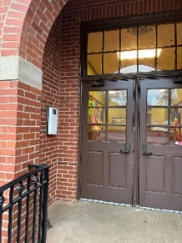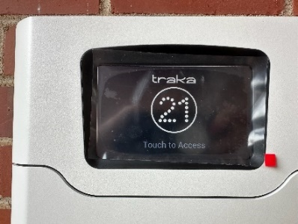
- The box will say “Enter Pin”. Pin Code given to you for your code is to be put onto this screen. Enter numerical code then press button.
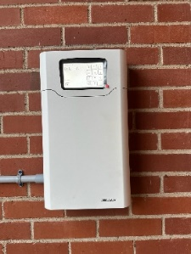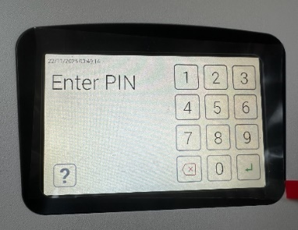
- Pull on door to open from the right side. Door will swing to the left. Keys will be hanging in as shown below. Key for the rental will be lit up green. Pull key from box. Shut door FULLY once key obtained.
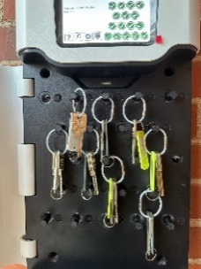
- Prior to leaving the facility after the event is over. Return the key to be box located adjacent to Double Middle Doors. Pull door down and drop in key and exit through the double door.
